
VILNIUS GEDIMINas Technical university
Faculty of Electronics
department of Electrnics systems

Machine Learning
Practical work 3
Authors: Kirill Postrehan, EDIfu 24/1
Lecturer: Dr. Olusola Oluwakemi Abayomi Alli

VILNIUS 2026
Introduction:
During this practical work I will use the dataset WineQT from Kaggle and analyze it using different types of charts.

Analysis & visualizations:
Univariate:
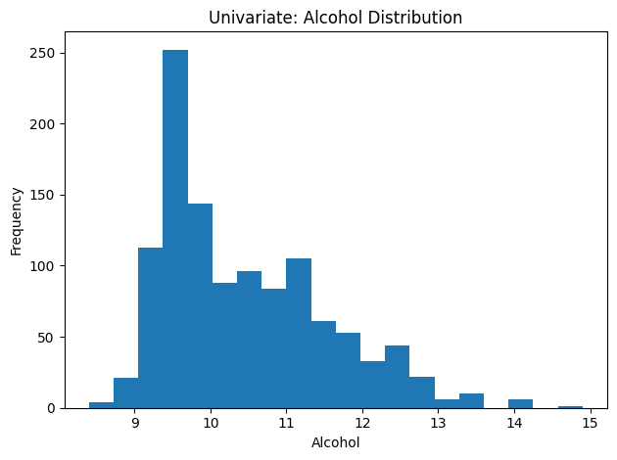
Categorical attribute in 1-D:
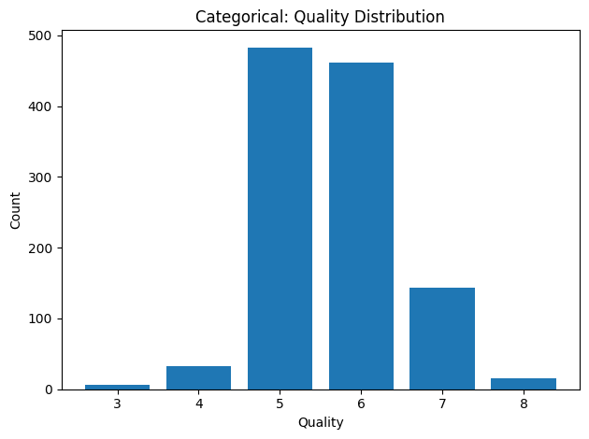
First, I analyzed the distribution of the quality variable using a bar chart. From the plot, it is clear that most wines have medium quality scores, while very low and very high quality wines are less common. This shows that the dataset is not perfectly balanced, which is important to keep in mind for further analysis.
Two Continuous Numeric attributes:
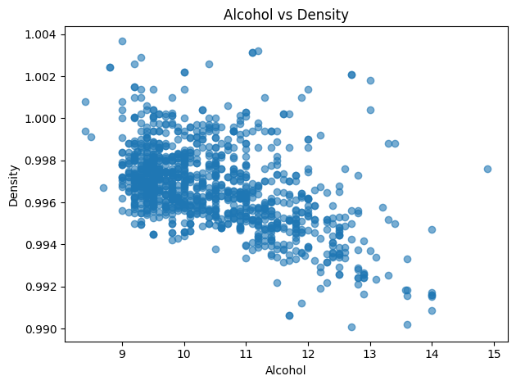
I created a scatter plot to analyze the relationship between alcohol content and wine quality. From the visualization, I noticed that wines with higher alcohol content generally tend to have higher quality scores. However, the relationship is not perfectly linear, and there are still some exceptions.
Joint Plot for alcohol and quality:

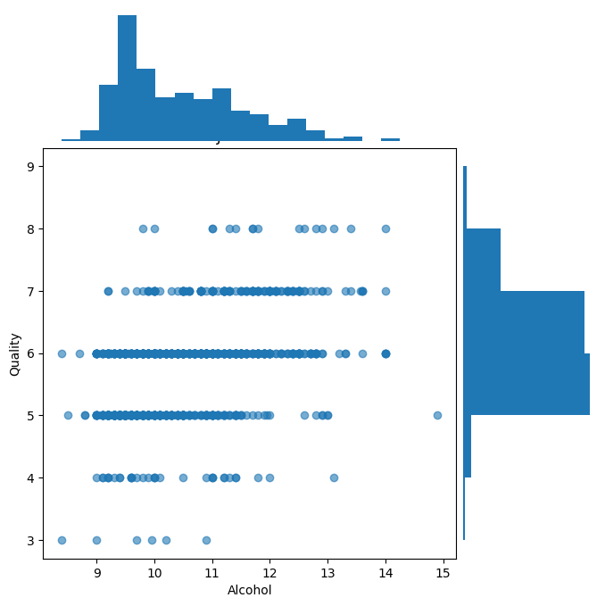
The joint plot helped me better understand the relationship between alcohol and quality by combining a scatter plot with distribution plots. It clearly shows that higher alcohol values are more frequent in wines with better quality ratings.

Boxplot:
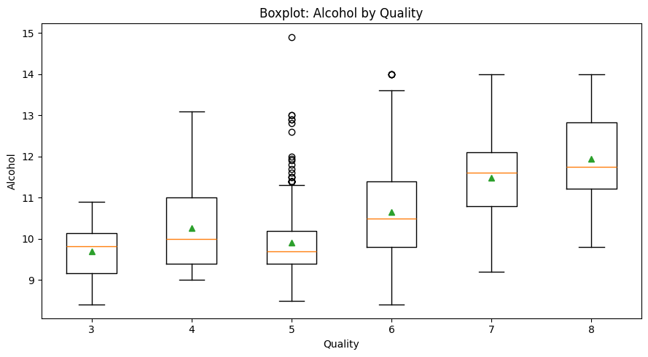
I used a boxplot to compare alcohol content across different quality levels. The plot shows that the median alcohol content increases as quality increases. It also highlights the presence of some outliers in certain quality categories.

Violin plot:
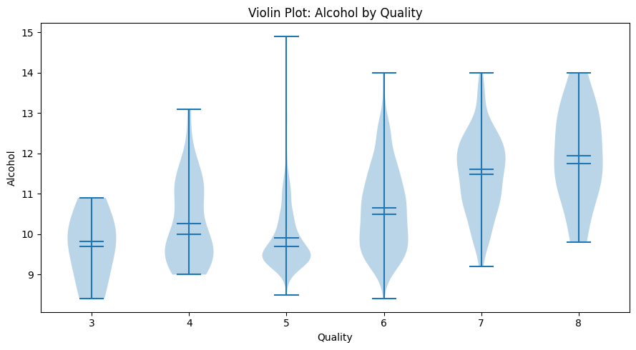
The violin plot provides more detailed information about the distribution of alcohol for each quality level. It confirms the trend observed earlier — higher quality wines usually have higher alcohol content. The shape of the distributions also shows how values are spread within each category.
Multivariate / High-Dimensional (Parallel Coordinates):
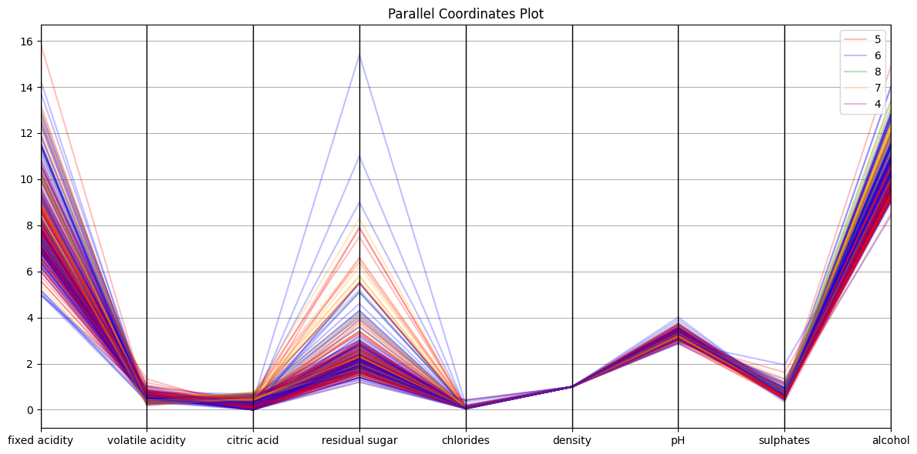
To analyze multiple features at the same time, I used a parallel coordinates plot. Each line represents one wine sample, and colors indicate different quality levels.
3D Scatter Plot:
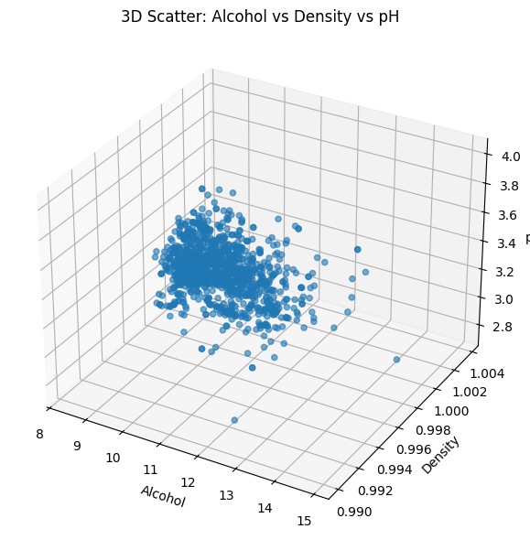
I also created a 3D scatter plot using alcohol, density, and pH. This plot helped visualize how three features interact together. It appears that wines with higher alcohol and lower density often correspond to higher quality scores.
Distribution of Alcohol Across Different Quality Levels :
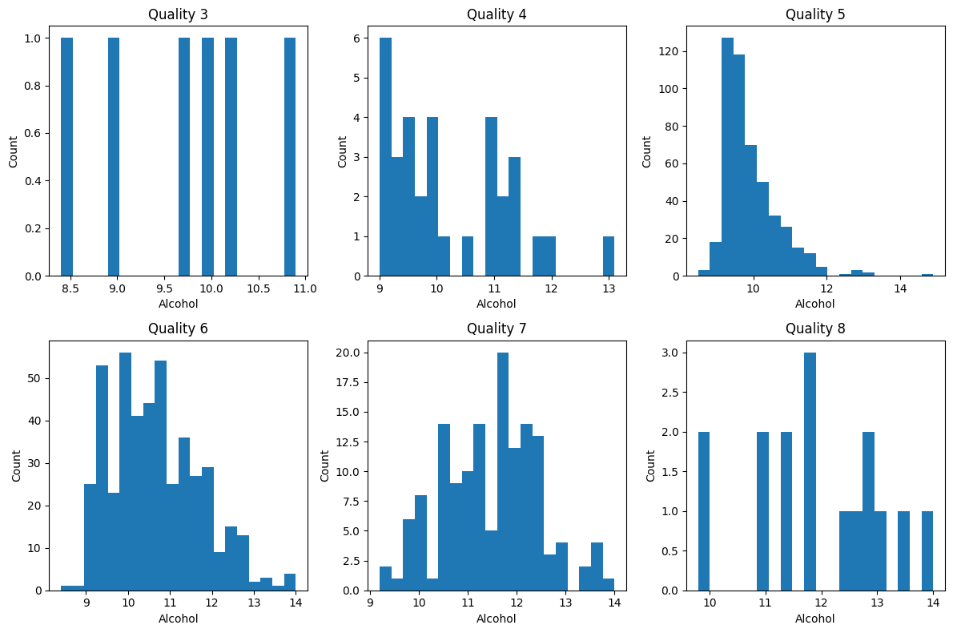
Finally, I compared alcohol distributions across quality levels using histograms. The results again show that alcohol content shifts toward higher values as wine quality increases. This confirms that alcohol is one of the most influential features in this dataset.

Conclusion:
In this practical work, K-Means clustering was used to identify four optimal clusters in the book dataset based on price and rating . Random genres were selected to represent these 4 clusters and later classified using a Multi-Layer Perceptron (MLP). After tuning hyperparameters, the model achieved about 95% accuracy with low loss, and evaluation metrics confirmed strong performance.

